**CLOUD COMPUTING**

ALEESHA KURIAN

S3 MCA

**INTRODUCTION**

Cloud computing is an emerging paradigm in the computer industry where the computing is moved to a cloud of computers. It has become one of the buzz words of the industry. The core concept of cloud computing is, quite simply, that the vast computing resources that we need will reside somewhere out there in the cloud of computers and we’ll connect to them and use them as and when needed.

Cloud computing is Internet-based computing, whereby shared resources, software, and information are provided to computers and other devices on demand, like the electricity grid. Cloud computing is a paradigm shift following the shift from mainframe to client–server in the early 1980s. Details are abstracted from the users, who no longer have need for expertise in, or control over, the technology infrastructure "in the cloud" that supports them.

**CLOUD COMPUTING**

Cloud computing is Internet based computing where virtual shared servers provide software, infrastructure, platform, devices and other resources and hosting to customers on a pay-as-you-use basis. All information that a digitized system has to offer is provided as a service in the cloud computing model.

Users can access these services available on the "Internet cloud" without having any previous know-how on managing the resources involved. Thus, users can concentrate more on their core business processes rather than spending time and gaining knowledge on resources needed to manage their business processes.

Cloud computing customers do not own the physical infrastructure; rather they rent the usage from a third-party provider. This helps them to avoid huge. They consume resources as a service and pay only for resources that they use. Most cloud computing infrastructures consist of services delivered through common centers and built on servers. Sharing resources amongst can improve, as servers are not unnecessarily left idle, which can reduce costs significantly while increasing the speed of application development.

**HISTORY**

Concept originated from telecommunication companies changing to VPN .

* 1999: Salesforce.com ‐ Delivery of applications via web
* 2002: Amazon launches Amazon Web Services (AWS)
* 2006: Google Docs, Amazon Elastic Compute Cloud (EC2)
* 2008: Eucalyptus
* 2009: Microsoft Azure

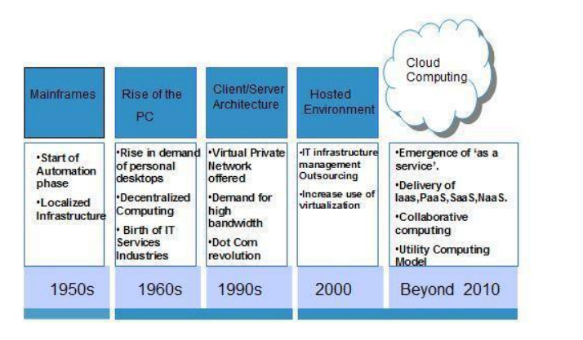

**ARCHITECTURE**

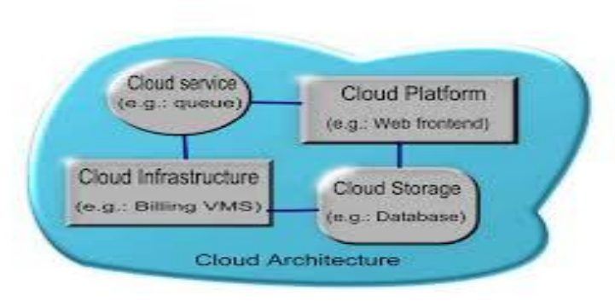

Cloud architecture, the systems architecture of the software systems involved in the delivery of cloud computing, typically involves multiple cloud components communicating with each other over application programming interfaces, usually web services. Cloud computing sample architecture This resembles the UNIX philosophy of having multiple programs each doing one thing well and working together over universal interfaces. Complexity is controlled and the resulting systems are more manageable than their monolithic counterparts. The two most significant components of cloud computing architecture are known as the front end and the back end. The front end is the part seen by the client, i.e. the computer user. This includes the client’s network (or computer) and the applications used to access the cloud via a user interface such as a web browser. The back end of the cloud computing architecture is the ‘cloud’ itself, comprising various computers, servers and data storage devices.

**COMPONENTS**

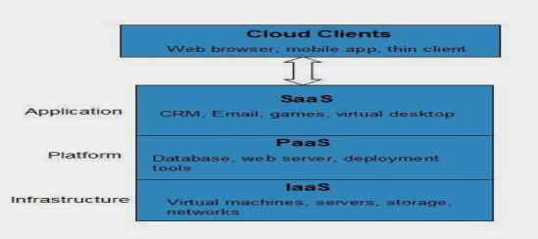

**SaaS (software as a service):** SaaS refers to software that’s made available as a web-based service. Because you can access the software remotely, you don’t need additional hardware to use or run it. Furthermore, you don’t have to worry about the software’s installation, setup, maintenance or upgrades. An example of SaaS is a site that allows you to create, save and access documents online.

**Utility computing:** The predecessor of cloud computing, utility computing provides the ability to access storage and virtual servers on demand.

**Cloud-based web services:** Similar to Saas, web services in the cloud allow you to offer services online, such as credit card processing services, employee payroll processing or viewing an interactive map. MSP (managed service providers): The grandfather of cloud computing, an MSP delivers applications to IT instead of end-users. An MSP example includes an email virus-scanning service.

**IaaS (infrastructure as a service):** IaaS refers to computer infrastructure (e.g., virtualization) that’s delivered as a service. A data center that offers outsourced software and servers may use IaaS for its operations.

**TYPES OF CLOUD COMPUTING**

**Public cloud:**

Public clouds are made available to the general public by a service provider who hosts the cloud infrastructure. Generally, public cloud providers like Amazon AWS, Microsoft and Google own and operate the infrastructure and offer access over the Internet. With this model, customers have no visibility or control over where the infrastructure is located. It is important to note that all customers on public clouds share the same infrastructure pool with limited configuration, security protections and availability variances. Public Cloud customers benefit from economies of scale, because infrastructure costs are spread across all users, allowing each individual client to operate on a low-cost, “pay-as-you-go” model. Another advantage of public cloud infrastructures is that they are typically larger in scale than an in-house enterprise cloud, which provides clients with seamless, on-demand scalability. These clouds offer the greatest level of efficiency in shared resources; however, they are also more vulnerable than private clouds.

A public cloud is the obvious choice when:

* Your standardized workload for applications is used by lots of people, such as e-mail.
* You need to test and develop application code.
* You need incremental capacity (the ability to add compute resources for peak times).
* You are doing collaboration projects.

**Private Cloud:**

Private cloud is cloud infrastructure dedicated to a particular organization. Private clouds allow businesses to host applications in the cloud, while addressing concerns regarding data security and control, which is often lacking in a public cloud environment. It is not shared with other organizations, whether managed internally or by a thirdparty, and it can be hosted internally or externally.

There are two variations of private clouds:

* **On-Premise Private Cloud**: This type of cloud is hosted within an organization’s own facility. A businesses IT department would incur the capital and operational costs for the physical resources with this model. On-Premise Private Clouds are best used for applications that require complete control and configurability of the infrastructure and security.
* **Externally Hosted Private Cloud**: Externally hosted private clouds are also exclusively used by one organization, but are hosted by a third party specializing in cloud infrastructure. The service provider facilitates an exclusive cloud environment with full guarantee of privacy. This format is recommended for organizations that prefer not to use a public cloud infrastructure due to the risks associated with the sharing of physical resources.

Private clouds are more expensive but also more secure when compared to public clouds. An Info-Tech survey shows that 76% of IT decision makers will focus exclusively on the private cloud, as these clouds offer the greatest level of security and control.

**Hybrid Cloud:**

Hybrid Clouds are a composition of two or more clouds (private, community or public) that remain unique entities but are bound together offering the advantages of multiple deployment models. In a hybrid cloud, you can leverage third party cloud providers in either a full or partial manner; increasing the flexibility of computing. Augmenting a traditional private cloud with the resources of a public cloud can be used to manage any unexpected surges in workload.

Hybrid cloud architecture requires both on-premise resources and offsite server based cloud infrastructure. By spreading things out over a hybrid cloud, you keep each aspect of your business in the most efficient environment possible. The downside is that you have to keep track of multiple cloud security platforms and ensure that all aspects of your business can communicate with each other.

Here are a couple of situations where a hybrid environment is best:

* Your company wants to use a SaaS application but is concerned about security.
* Your company offers services that are tailored for different vertical markets. You can use a public cloud to interact with the clients but keep their data secured within a private cloud.
* You can provide public cloud to your customers while using a private cloud for internal IT.

**ADVANTAGES**

The following are some of the possible advantages of cloud computing:

**Flexibility** : There is a high rate of flexibility when using cloud computing because people can opt out of using it whenever they want too. One of the major benefit of cloud computing is that there is no limitation of place and medium. We can access our applications and data anywhere in the world, on any system. These are the main reasons, which attract people to use this method.

**Low Cost** : Companies can save big by employing cloud computing as it eliminates cost for hardware and software. With cloud computing, company uses the resources of the hosting company to store their data and applications. Companies also pay for use of the software and programs by paying a subscription fee. The cost of using cloud resources is very economical for resources such as centralized, real estate, bandwidth, and power. Users will also save money on software updates, management costs, and data storage costs. It is a cheaper way to maintain the software and it will save time, as the developers keep track of updates and maintain your programs while you use it.

**Speed & Scales**: Traditional methods to buy and configure hardware and software are time consuming. There is no need to purchase and setup hardware manually when using the cloud computing method. Cloud computing provides a rapid deployment model that enables applications to grow quickly to match increasing usage requirements. Depending upon their needs the user can quickly scale up or scale down.

**Easier Management of Data and Information** : Since all data are located on a centralized location, data are more organized making it easy to manage. All transactions are also recorded so management can easily track activities of their employees.

**Device Diversity**: We can access our applications and data anywhere in the world, on any system. Cloud Computing Services can be accessed through various different electronic devices that are able to have access to the internet. These devices would include and i pad, Smartphone, Laptop, or desktop computer.

**Increased Storage Capacity** : Increased Storage Capacity is another benefit of the cloud computing, as it can store more data as compared to a personal computer. So it saves us from the upgrading computer memory that helps reduce the cost for companies and users.

**Easy to Learn and Understand**: Thus allowing you to save hundreds and thousands of dollars in implementing any new system and making arrangements for training on the same. Since people are quiet used to cloud applications like GMail, Google Docs, so anything related to the same is most likely to be understood by the users.

**Automatic Updating** : It saves companies time and effort to update multiples server. On the other hand, it also helps users to download updates for the software. Once the server gets updated the users can get the updates without doing anything.

**Customize Setting**: Cloud computing also allows you to customize your business applications. This is a great benefit because the world of online business is very competitive.

**DISADVANTAGES**

The following are some of the possible disadvantages of cloud computing:

**Dependency**: One major disadvantages of cloud computing is user’s dependency on the provider. Internet users don’t have their data stored with them.

**Risk** : Cloud computing services means taking services from remote servers. Â There is always insecurity regarding stored documents because users do not have control over their software. Nothing can be recovered if their servers go out of service.

**Requires a Constant internet connection**: The most obvious disadvantage is that Cloud computing completely relies on network connections. It makes your business dependent on the reliability of your Internet connection. When it’s offline, you’re offline. If you do not have an Internet connection, you can’t access anything, even your own data. A dead internet connection means no work. Similarly, a low-speed Internet connection, such as that found with dial-up services, makes cloud computing painful at best and often impossible. Webbased apps often require a lot of bandwidth to download, In other words, cloud computing isn’t for the slow connection.

**Security** : Security and privacy are the biggest concerns about cloud computing. Companies might feel uncomfortable knowing that their data is stored in a virtual server which makes responsibility on the security of the data difficult to determine and even users might feel uncomfortable handing over their data to a third party. Privacy is another big issue with the cloud computing server. To make cloud servers more secure to ensure that a clients data is not accessed by any unauthorized users, cloud service providers have developed password protected accounts, security servers through which all data being transferred must pass and data encryption technique.

**Migration Issue** : Migration problem is also a big concern about cloud computing. If the user wants to switch to some other Provider then it is not easy to transfer huge data from one provider to another.

**CONCLUSION**

Cloud computing is a powerful new abstraction for large scale data processing systems which is scalable, reliable and available. In cloud computing, there are large self-managed server pools available which reduces the overhead and eliminates management headache. Cloud computing services can also grow and shrink according to need. Cloud computing is particularly valuable to small and medium businesses, where effective and affordable IT tools are critical to helping them become more productive without spending lots of money on in-house resources and technical equipment. Also it is a new emerging architecture needed to expand the Internet to become the computing platform of the future.

Cloud computing is a really cheap way for companies to have all the resources they need in once place. It’s a much better way to spread your resources, and it becomes easier to access things from longer distances.

**REFERENCES**

1. http://www.spinnakerlabs.com/CloudComputing.pdf

“Welcome to the new era of cloud computing PPT”

2. www.studymafia.org